# File permissions in Linux

## Project description

In this project, I aim to show that I am capable of changing permissions in the bash shell so that users, groups, and others have the correct permissions, as well as show that I understand the underlying concepts.

## Check file and directory details

In order to check both files and their permissions in the bash shell, use ls -la

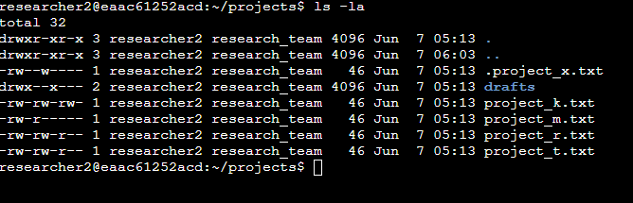

## Describe the permissions string

The permissions string is the 10-character string before the user and group that owns the file. The first character will either be – or d, indicating if it’s a file or directory. The characters r,w, and x are used to show permissions that the user, group, and all other users have for the file or directory. Full permissions for all users for a file would look like -rwxrwxrwx; the first set of rwx would be for the user, the second set for the group, and the third set for all others.

## Change file permissions

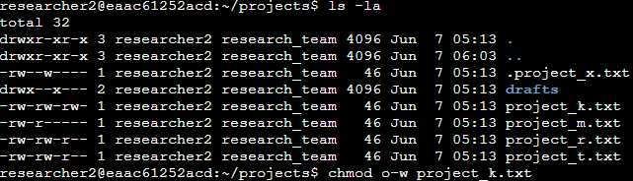

In the above example, other users are not allowed to have any write permission on any file – therefore, we change the other permission by specifying other users with “o” and then taking away the write permission with “-w”.

## Change file permissions on a hidden file

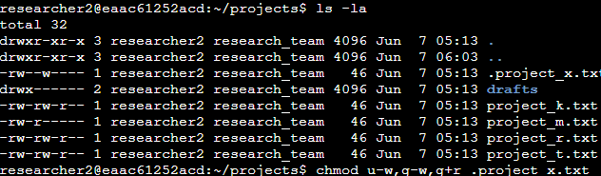

In the above example, .project_x.txt is a hidden file, and hidden files are archived and cannot allow write permissions at all. However, user and group must have read permission. Therefore, I used chmod to change multiple permissions to make sure that the correct permissions are given to the user and group.

## Change directory permissions

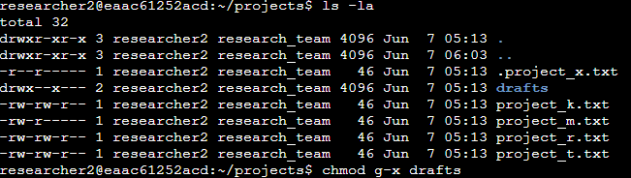

In this example, you can see that the drafts directory has execute permissions for the group. However, if you do not want the group to have this permission, you can simply remove it by using g-x, the same way you would for normal files.

## Summary

Managing authorization in Linux is pretty simple when you use bash correctly. Using a combination of ls -la to see which permissions which files have (even hidden ones) and chmod to change them are powerful tools to manage access to your files.